Uterine Cervix

# Truth versus WSI (Leica)

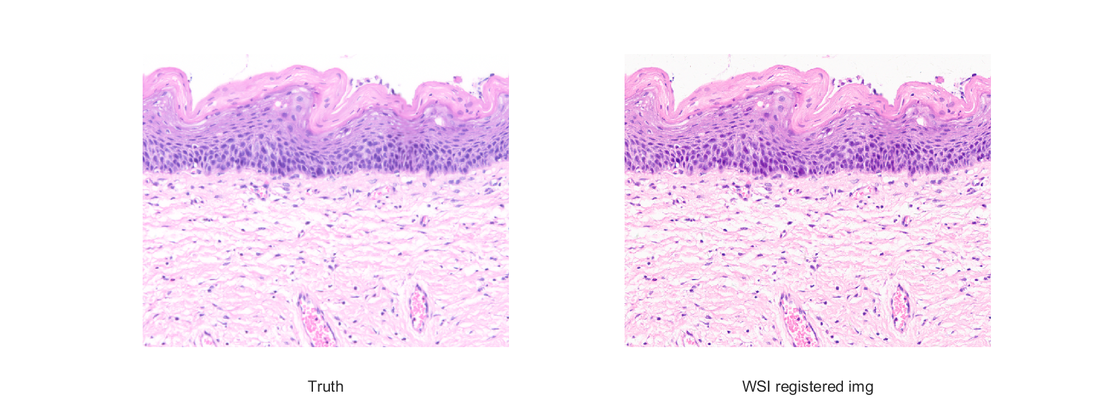

CIELAB difference using the SRGB values from the WSI image and the CIELAB values form the measurements of the truth by the HIMS

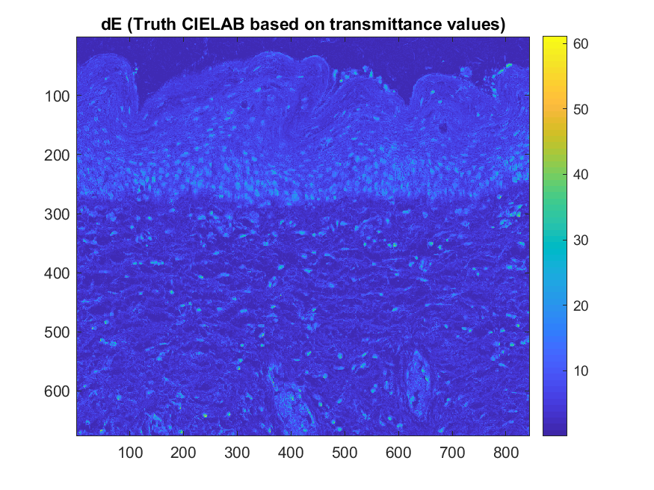

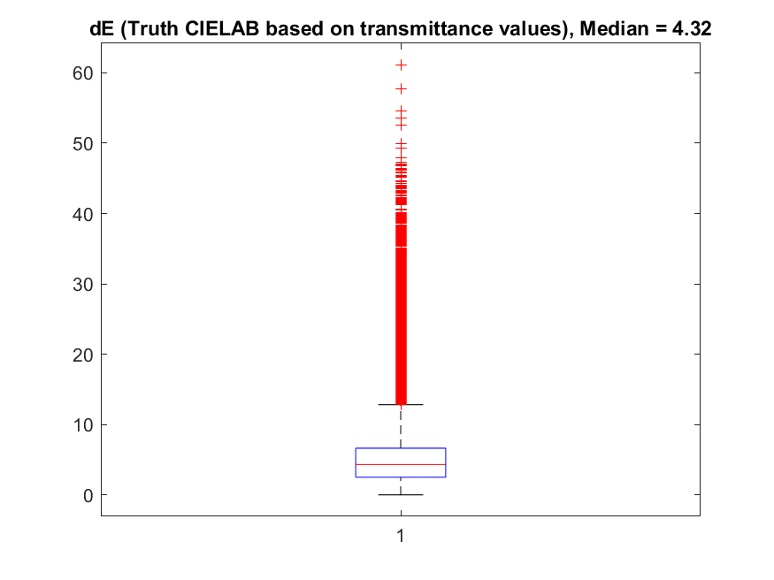

# Principal component analysis

Reconstruction of spectra for a sample of 20-or-so pixels chosen over the image using 5 eigenvectors

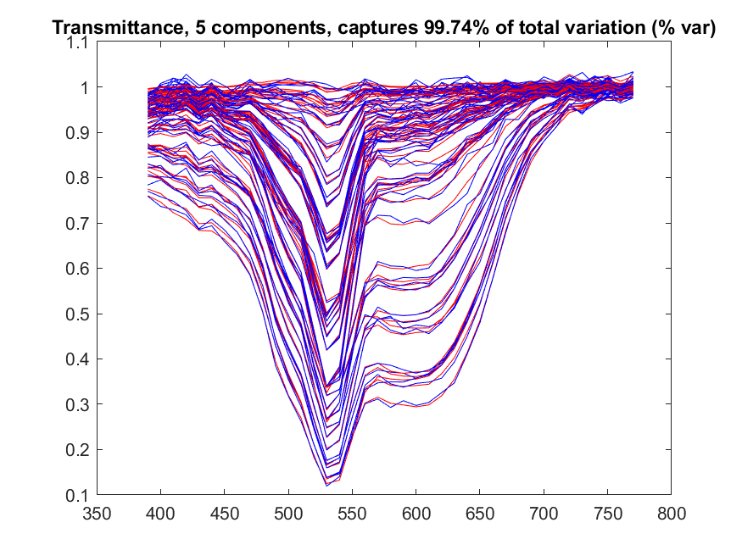

Reconstruction of spectra of one pixels using 5 eigenvectors

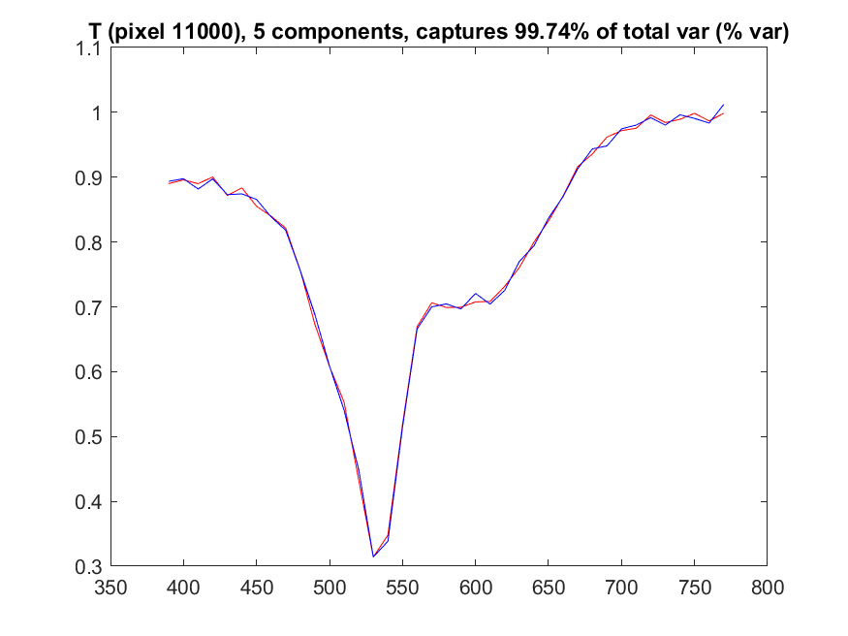

Reconstruction of mean spectra of the image using 5 eigenvectors

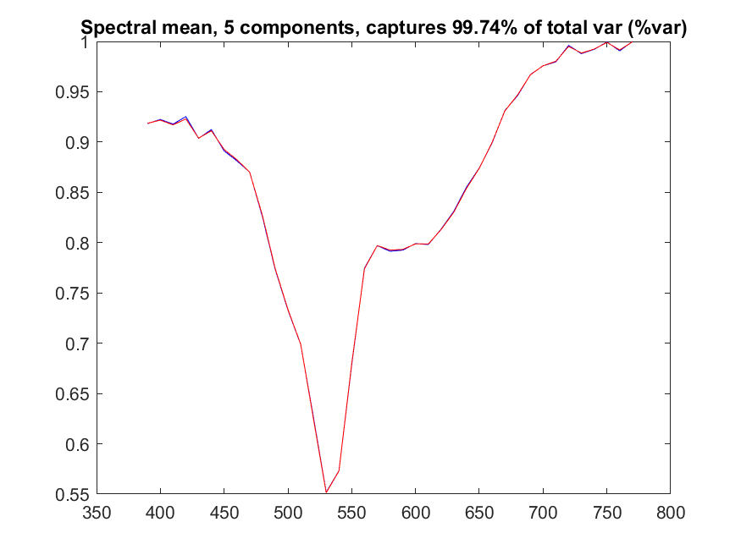

Difference between original Truth image and the one reconstructed using 5 eigenvectors

